**Back pain**

**Initial Assessment**

|  |  |  |
| --- | --- | --- |
| **Presenting Symptom/Chief Complaint** | | |
| Acute painful back obstruction syndrome due to sprain and cold and QI stagnation. | | |
| **Main Signs and Symptoms** | | |
| Back painful stiffness of the back muscle due to cold. | | |
| **Other Signs and Symptoms** | | |
| No sciatica, acute sprain of low back pain with stagnation of the QI | | |
| **TCM Diagnosis and Treatment (identified TCM disease, TCM differentiation of syndromes)** | | |
| Acute pain, back obstruction syndrome due to sprain of the back muscle. Positive QI stagnation. | | |
| **Treatment Principles and Strategies** | | |
| Remove muscle spasm, eliminate wind, and increase of QI movement. | | |
| **Treatment Plan (Modalities; acupuncture, herbal, dietary, manual therapies), frequency and duration** | | |
| Acupuncture: Distal joints with reduction method, plus local point tonification-2 times a week for 1 hour. Combination of source and back SHU points. | | |
| **Any other Advice Given to Patients** | | |
| Acupuncture: UB23(bilateral), UB 26(bilateral), Shigizhuixia, Jao Yan(L4-L5). Distal Points with reduction. UB60 (bilateral), UB40, UB 62, K4 (bilateral). | | |
| **Practitioner:** | **Date:** | **Signature:** |

**Daily Charting____________________________________Patient Name:**

**Date: June 13, 2015_______________**

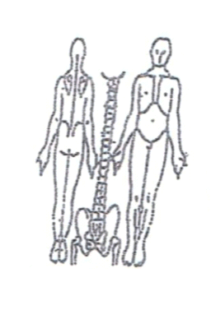 **Working Diagnosis:** Acute pain, back obstruction syndrome, due to

sprain of the back muscle. Possible QI stagnation.

S: Acute back pain aggravated by cold wind. ROM pain with walking. sleep. movement.

O:

Treatment (P) Acupuncture: UB23(bilateral), UB 26(bilateral), Shigizhuixia, Jao **Yan**(L4-L5). Distal Points with reduction. UB60(bilateral), UB40, UB 62, K4 (bilateral).

* Acupuncture with distal points sedation
* (15 min)+ tonification (45 min) local points.

**Date: June 17, 2015______________**

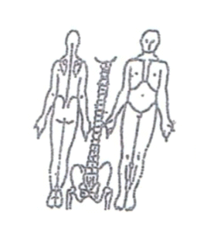**Working Diagnosis:**

S: Symptoms better, pain 2-3 of the scale.

O: Sleep better. Pain with walking.

Treatment (P) Acupuncture + Moxa 1 hour according to the protocol.

(A)

**Date: June 20, 2015_______________**

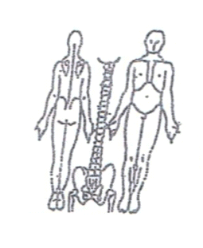**Working Diagnosis:**

S: N movement. Pain 1-2 of the scale. N ROM. N sleep.

O:

Treatment (P) Acupuncture: 1 hour+ stretching exercises.

(A)

**Date: June 24, 2015______________**

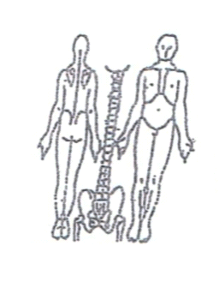**Working Diagnosis:**

S: No symptoms. No pain.

O: N movement. N sleep. Full ROM

Treatment (P) Acupuncture 1 hour.

(A)

**Date:__ June 27, 2015______________**

**Working Diagnosis:**

S: No symptoms. No pain.

O: N movement. N sleep. Full ROM

Treatment (P) Acupuncture 1 hour.

(A)

**Daily Charting____________________________________Patient Name:**

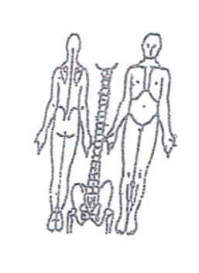**Date: June 30, 2015____________**

**Working Diagnosis:**

S: N movement. N sleep. Full ROM

O:

Treatment (P)

(A)